**University of Management and Technology, Lahore Campus**

**Lab- 06 Manual**

Lab Instructor: Riaz Ahmad

Department of Computer Science

Email: [riazahmad@umt.edu.pk](mailto:riazahmad@umt.edu.pk)

**Increment /Decrement operator & While Loop**

**Coding Examples:**

**Decrement operator:**

include <iostream>

using namespace std;

int main()

{

int x=10,a;

a=--x;

cout<<"pre decrement operator";

cout<<"\na = "<<a;

cout<<"\nx ="<<x;

return 0;

}

**Output:**

Pre decrement operator

a=9

x=9

include <iostream>

using namespace std;

int main()

{

int x=10,a;

a=x--;

cout<<"Post decrement operator";

cout<<"\na = "<<a;

cout<<"\nx ="<<x;

return 0;

}

**Output:**

a=10

x=9

**Increment Operator:**

include <iostream>

using namespace std;

int main()

{

int x=10,a;

a=++x;

cout<<"pre increment operator";

cout<<"\na = "<<a;

cout<<"\nx ="<<x;

return 0;

}

**Output:**

Pre increment operator

a=11

x=11

include <iostream>

using namespace std;

int main()

{

int x=10,a;

a=x++;

cout<<"Post increment operator";

cout<<"\na = "<<a;

cout<<"\nx ="<<x;

return 0;

}

**Output:**

Post increment operator

a=10

x=11

**While Loop:**

* **Loop: a control structure that causes a statement or statements to repeat**
* **General format of the while loop:**

**while (*expression*)**

***statement*;**

* ***statement*; can also be a block of statements enclosed in { }**

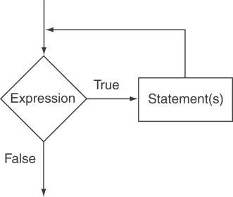

**Example 1: Write a program using while loop that show the sum of first five numbers.**

**Code:**

#include<iostream>

using namespace std;

int main()

{

int number=1,sum=0;

while(number<=5)

{

sum=sum+number;

number++;

}

cout<<"Sum is "<<sum;

return 0;

}

**Execution Process:**

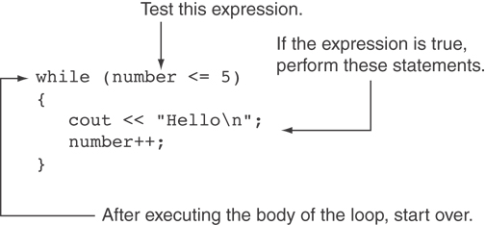

**Flow chart:**

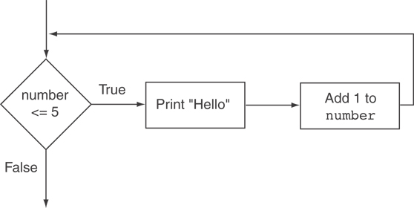

**Example 2: Write a program for take input the list of numbers and print their squares.**

**Code:**

#include <iostream>

using namespace std;

int main()

{

int minimum=1;

int maximum=10;

int num=minimum;

cout<<"Number number squared \n ";

while(num<=maximum)

{

cout<<num<<"\t\t"<<num*num<<endl;

num++;

}

return 0;

}

**Output:**

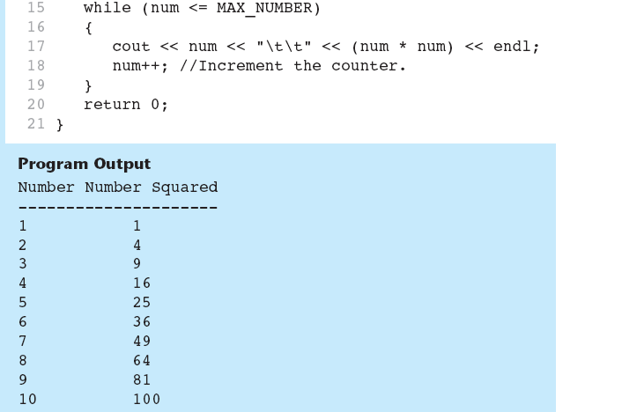

**Example 3: Write a program in C++ to find the factorial of a number.**

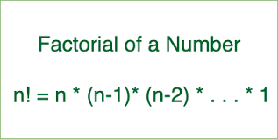

#include <iostream>

using namespace std;

int main()

{

int n;

cout<< "Input a number to find the factorial:";

cin>>n;

int factorial = 1;

int i = 1;

while (i <= n)

{

factorial = factorial*i;

i++;

}

cout << factorial;

}

**Example 4: A class of ten students took a quiz. The grades (integers in the range 0 to 100) for this quiz are available to you. Calculate and display the total of all student grades and the class average on the quiz.**

#include <iostream>

using namespace std;

int main()

{

int total; // sum of grades entered by user

int gradeCounter; // number of the grade to be entered next

int grade; // grade value entered by user

double average; // average of grades

// initialization phase

total = 0; // initialize total

gradeCounter = 1; // initialize loop counter

// processing phase

while ( gradeCounter <= 10 ) // loop 10 times

{

cout << "Enter grade: "<<gradeCounter; // prompt for input

cin >> grade; // input next grade

total = total + grade; // add grade to total

gradeCounter = gradeCounter + 1; // increment counter by 1

} // end while

// termination phase

average = total / 10; // integer division yields integer result

// display total and average of grades

cout << "\nTotal of all 10 grades is " << total << endl;

cout << "Class average is " << average << endl; }

**Formulating Algorithms (Sentinel-Controlled Repetition)**

**Example 5: Develop a class averaging program that will process an arbitrary number of grades each time the program is run.**

# include <iostream>

# include <iomanip>

using namespace std;

int main()

{

int total, // sum of grades

gradeCounter, // number of grades entered

grade; // one grade

float average; // average of grades

// initialization phase

total = 0; // Clear total

gradeCounter = 0; // prepare to loop

// processing phase

cout << "Enter grade, type -1 to indicate the end outer: ";

cin >> grade; // input grade

while ( grade != -1) // loop until -1 is entered

{

total = total + grade; // add grade to total

gradeCounter = gradeCounter + 1; // increment counter

cout << "Enter grade, type -1 to indicate the end inner: ";

cin >> grade;

}

// termination phase

if ( gradeCounter != 0 )

{

average = static_cast< float >( total ) / gradeCounter;

cout << "Class average is " << setprecision( 2 ) <<fixed<< average << endl;

}

else

{

cout << "No grades were entered"<<endl;

}

return 0; //indicate program ended successfully

}

**Example 6: A college has a list of test results (1 = pass, 2 = fail) for 10 students. Write a program that analyzes the results. If more than 8 students pass, print "Raise Tuition".**

//Analysis of examination results

#include <iostream>

using namespace std;

int main()

{

// initialize variables in declarations

int passes = 0, // number of passes

failures = 0, // number of failures

studentCounter = 1, // student counter

result; // one exam result

// process 10 students; counter-controlled loop

while ( studentCounter <=10 )

{

cout << "Enter result (1=pass, 2=fail): ";

cin >> result;

if ( result == 1) // if/else nested in while

{

passes = passes + 1;

}

else

{

failures = failures + 1;

}

studentCounter = studentCounter + 1;

}

// termination phase

cout << "Passed " << passes << endl;

cout << "Failed " << failures << endl;

if ( passes > 8 )

{

cout<< "Raise tuition " << endl;

}

return 0;

// successful termination

}

**Example 7: Write a program to Printing and count Even and Odd Numbers using While Loop in C++.**

#include<iostream>

using namespace std;

int main()

{

int i=1,n,even=0,odd=0;

cout<<"\nEnter the Ending value:";

cin>>n;

while(i<=n)

{

if(i%2==0)

{

cout<<"\nEven numbers:";

cout<<"\n"<<i;

even++;

}

else

{

cout<<"\nOdd numbers:";

cout<<"\n"<<i;

odd++;

}

i++;

}

cout<<"\nTotal even numbers:"<<even;

cout<<"\nTOtal odd numbers:"<<odd;

return 0;

}

OR

#include<iostream>

using namespace std;

int main()

{

int i=1,n,even=0,odd=0;

cout<<"\nEnter the Ending value:";

cin>>n;

cout<<"\nEven numbers:";

while(i<=n)

{

if(i%2==0)

{

cout<<"\n"<<i;

even++;

}

i++;

}

cout<<"\nOdd numbers:";

i=1;

while(i<=n)

{

if(i%2==1)

{

cout<<"\n"<<i;

odd++;

}

i++;

}

cout<<"\nTotal even numbers:"<<even;

cout<<"\nTOtal odd numbers:"<<odd;

return 0;

}

**Example 8: Write a program to check Even and Odd Numbers using While Loop on the basis of user choice in C++.**

#include <iostream>

using namespace std;

int main()

{

int choice = 1;

while( choice == 1 )

{

int a;

cout << "Enter a number to check even or odd" << endl;

cin >> a; //input number

//check whether number is even or odd

if( a%2 == 0 ){

cout << "Your number is even" << endl;

}

else{

cout << "Your number is odd" << endl;

}

cout << "Want to check more : 1 for yes and 0 for no" << endl;

cin >> choice;

}

cout << "I hope you checked all your numbers" << endl;

return 0;

}